🌳 Java Collections Framework Hierarchy
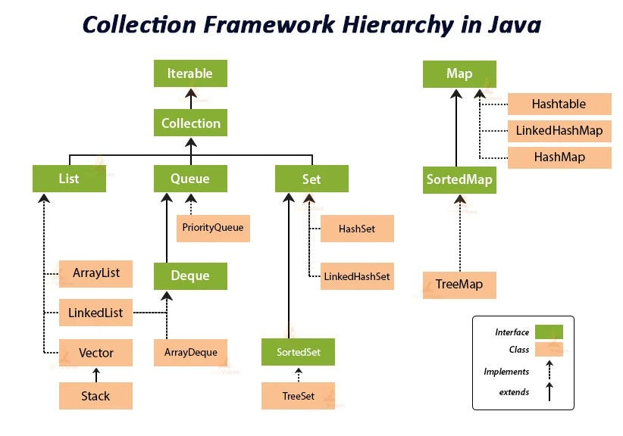

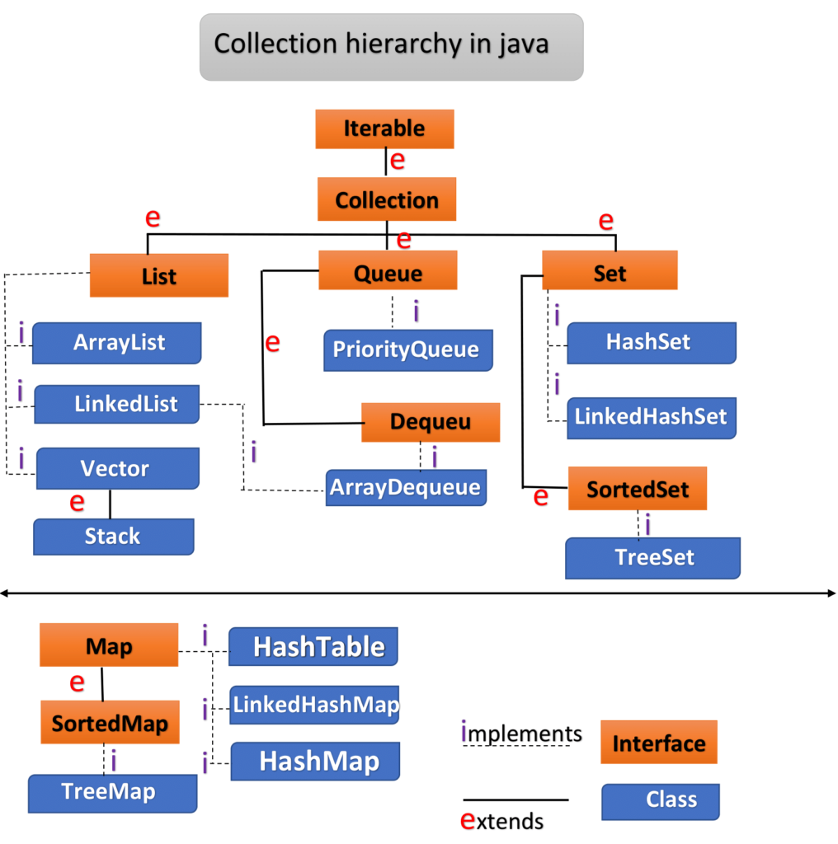
4

🔷 1️⃣ Iterable (Top Most Interface)
Everything in collections starts from:
Iterable<T>
It defines:
Iterator<T> iterator();
This enables:
for(String s : list)
Enhanced for-loop works because of Iterable.

🔷 2️⃣ Collection Interface
public interface Collection<E> extends Iterable<E>
This is the root of:
- List
- Set
- Queue
It defines basic operations:
add()
remove()
size()
isEmpty()
contains()
clear()
iterator()

🔹 Important:
Map is NOT part of Collection.
It has a separate hierarchy.

🔷 3️⃣ List Interface
Characteristics
- Ordered
- Allows duplicates
- Indexed access
- Preserves insertion order

Common Implementations
- ArrayList
- LinkedList
- Vector
- Stack

Example
List<String> list = new ArrayList<>();
list.add("A");
list.add("A"); // allowed
list.get(0); // index based

When to Use List?
- You need ordering
- You need duplicates
- You need index access

🔷 4️⃣ Set Interface
Characteristics
- No duplicates
- No index
- May or may not preserve order (depends on implementation)

Implementations
- HashSet
- LinkedHashSet
- TreeSet

Example
Set<String> set = new HashSet<>();
set.add("A");
set.add("A"); // ignored

When to Use Set?
- Uniqueness required
- Fast lookup
- Removing duplicates

🔷 5️⃣ Queue Interface
Represents:
Data structure designed for processing elements before processing.
Mostly FIFO (First In First Out)

Implementations
- LinkedList
- PriorityQueue
- ArrayDeque

Example
Queue<Integer> queue = new LinkedList<>();
queue.offer(10);
queue.poll();

Special Types
- FIFO → LinkedList
- Priority-based → PriorityQueue
- Double-ended → Deque

🔷 6️⃣ Map Interface (Separate Hierarchy)
Very Important:
Map<K, V>
Does NOT extend Collection.
Because it stores:
Key–Value pairs
Not individual elements.

Core Methods
put()
get()
remove()
containsKey()
containsValue()
keySet()
values()
entrySet()

Implementations
- HashMap
- LinkedHashMap
- TreeMap
- Hashtable

🔥 Why Map Is Separate?
Collection deals with:
Collection<E>
Map deals with:
Map<K, V>
Two generics instead of one.
Conceptually different structure.

🧠 Core Differences Summary
Interface | Allows Duplicates | Maintains Order | Indexed | Key-Value
List | ✅ | ✅ | ✅ | ❌
Set | ❌ | Depends | ❌ | ❌
Queue | ✅ | FIFO | ❌ | ❌
Map | Keys ❌ | Depends | ❌ | ✅

🔥 Very Important Interview Insight
If interviewer asks:
Why does Map not extend Collection?
Answer:
Because Map represents key-value mappings,
while Collection represents single-element groups.
The abstraction is fundamentally different.

🧠 Mental Model
Iterable
↓
Collection
├── List (ordered, duplicates)
├── Set (unique elements)
└── Queue (processing order)
Map (separate branch – key/value pairs)

🚀 Advanced Thinking
Most performance-based questions will involve:
- HashMap
- HashSet
- ArrayList
- LinkedList
Understanding these core interfaces is foundation for that.

